**Requirements Analysis Documents**

**TABLE OF CONTENTS**

1 Introduction 3

1.1 Purpose of the system 3

1.2 Scope of the system 3

1.3 Core System Functionalities 3

1.4 Objectives and Success Criteria of the Project 4

1.5 Definitions, Acronyms and Abbreviations 4

2 Proposed System 5

2.1 overview 5

2.2 Functional Requirements 5

2.3 Nonfunctional Requirements 5

2.3.1 Usability 5

2.3.2 Reliability 6

2.3.3 Performance 6

2.3.4 Supportability 6

2.3.4 Implementation 6

2.4 System Models 7

2.4.1 User case model 7

2.4.2 Object model 7

2.4.3 User Interface –Navigational Paths and Screen Mock-ups 7

# Introduction

## Purpose of the system

The purpose of this project is that customer can practice the skill of trading in stock market. At the same time, the customer also can get some knowledge of stock market rules, operation ways and soon. This document will provide detail of requirements and the primary task of each group member.

## Scope of the system

This project is a website of stock market game. In this website, customer just needs register account and login the website, then the customer can start the game without any download. The website support many users online in the same time.

## Core System Functionalities

The website must be able to:

* Allow more than one user online in the same time
* Providing a search function which can help customers to find the special stock.
* Providing a stock list to help customers to view the stock which exist in the stock market.
* Providing a selling & buying function that customers can make trading online.
* Providing alarm function that customer make a alarm number for their own stocks.
* Providing a friend function that users can make communications between users.
* Providing a transfer function that user can borrow/receive money from friends.
* Providing an initial found for each user.
* Providing a history function that user can view the history of trading
* Providing a profile page that user view the information about himself/herself.
* Providing a curve of stock so that user can see the changes of price during the certain time.

## Objectives and Success Criteria of the Project

The success of the website depends upon meeting the following core set of objectives:

* The design of search function should be supported to provide tips for users
* The design of buying and selling capability
* The design of communication and friend functions
* Showing the real data in stock list and curve
* The website connect to database which can record/ acquire information between website and database.

## 1.5 Definitions, Acronyms and Abbreviations

|  |  |
| --- | --- |
| Terms/concepts | Explanation |
| user | Any customer that interacts with the system |
| game | A virtual trading about stock market |
| dashboard | Provide stock list and search function |
| stock | The stock (also capital stock) of a corporation is constituted of the equity stock of its owners. |
| symbol | Each company only have one symbol to identify |
| Last price | Show the price of a stock in the last time |
| Change rate | The rate is the percentage of change price in current price |
| Change price | The change number about current price and last price |
| Leader Board | Prove the users list and situation of each user |
| Cash | The money that user can be used |
| Assert | The money that user already used |
| Net Worth | The totally number of cash and profits |
| Quote | Check the situation of special stock |
| System | Any interactions performed by the website are considered to be performed by the system. |
| Number of shares | The number of shares for buying or selling |
| Alarm Price | The price that will send email to users for warning |
| Message | Provide communication function between users |
| Friend | Provide friend function for users , then they can do more things |
| transfer | Provide transfer function between friends |

# 2 Proposed System

## 2.1 overview

This section provides a functional overview of the system. This will again be properly be divided into two parts.

## 2.2 Functional Requirements

* The customer must have an account to login the website
* The customer should provide the username, password, and email and phone number when doing registration.
* The user must be able to view the situation of all stock
* The user must be able to buy some stocks
* Each user have a history of trading
* The user must be able to sell some stocks
* Each user can edit his/her information in profile page
* The user should be able to add other users
* The user should be able to communicate to other users
* The user should be able to transfer money to his/her friends
* The cash, assets and net worth of each user should be showed in current page
* The user should be able to search a special stock
* The user should be able to make an alarm for the stock
* The user should be able to view the curve of stock which user already buying

## 2.3 Nonfunctional Requirements

### 2.3.1 Usability

* Search function provides tips when user use it
* User can get tips when user receive new messages
* When user add other users, the system will send accept message to other users
* The creation of friend relationship should get agree from both sides
* When the price of stock reach to the warning number, the user should be able to get an email which talking about this things
* When the number of buying over the number of cash, the user can get error page which talk about it
* When the number of selling over the number of shares, the user can get error page which talk about it

### 2.3.2 Reliability

Each function will be tested to ensure that they are functional. Final, all functions will be working great. Otherwise, all testing will through manual testing to ensure the highest chance of being quality code

### 2.3.3 Performance

* The running of each function is perfect without any delay.
* Search function will reduce the time of checking the name of stock
* Users will easy to find the history through the way of choosing the time

### 2.3.4 Supportability

User can login/register an account in any time or place without download the application

### 2.3.4 Implementation

Project will be implemented in Python

All project graphical user interfaces will be created using CSS, html and JS.

The getting of stock data will use yahoo finance API.

## 2.4 System Models

### 2.4.1 Use case model

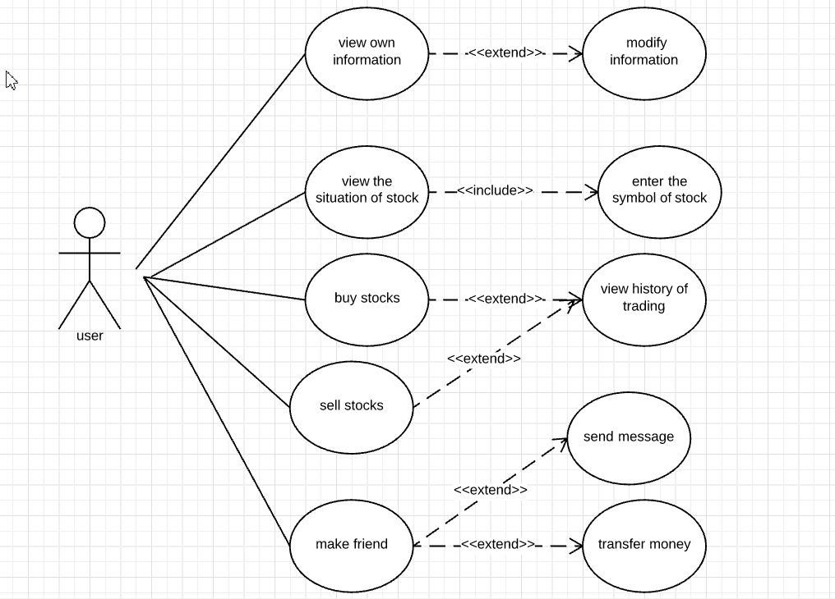

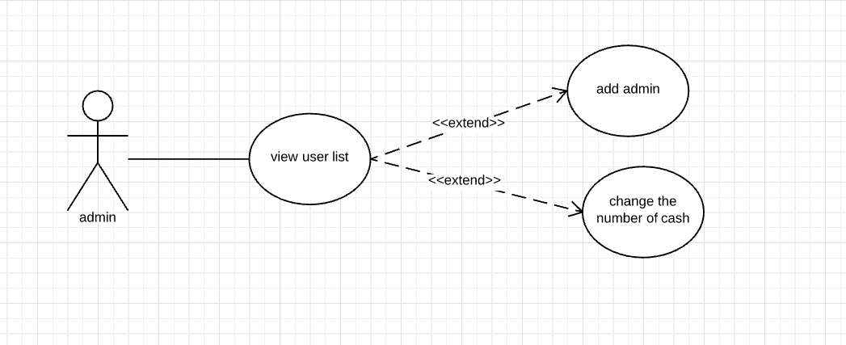

### 2.4.2 Object model

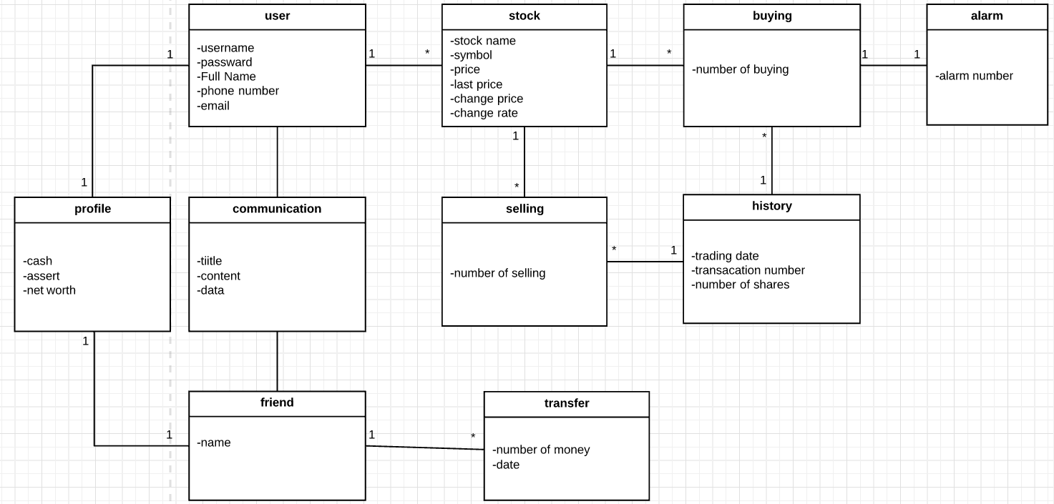

### 2.4.3 User Interface –Navigational Paths and Screen Mock-ups



Figure1-guide line

Dashboard: 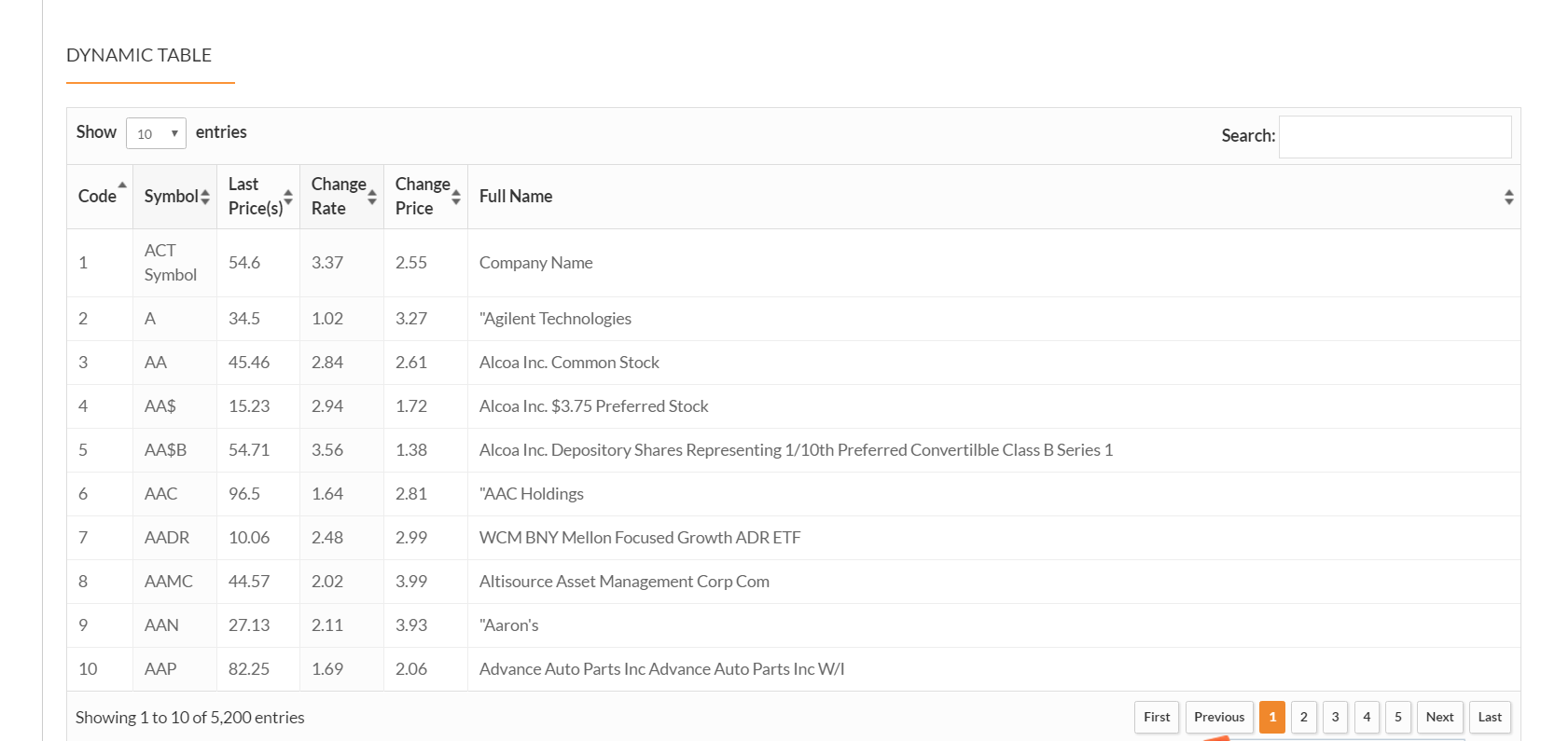

Figure 2- Dashboard

In this page, it provides the data of all stock. User can the detail of each stock. Otherwise, this page also provides search function, user can use search function to find a special stock.

Service:

In the service part, it has three functions which are buying, selling and quote.

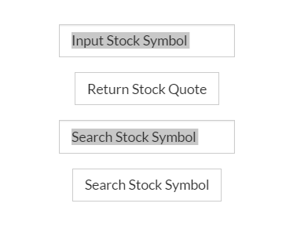 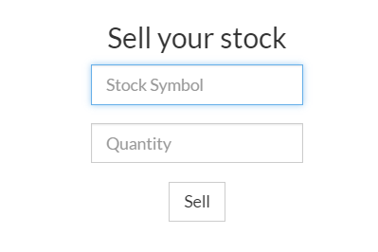 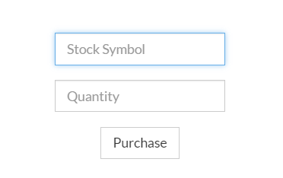

Figure 3-quote, selling && buying

In quote part, user can check the information of one special stock. In the selling part, user can choose the stock and number to sell. In the buying part, it similar with selling part. User also should choose stock at first and then enter the number of this stock.

Leaderboard:

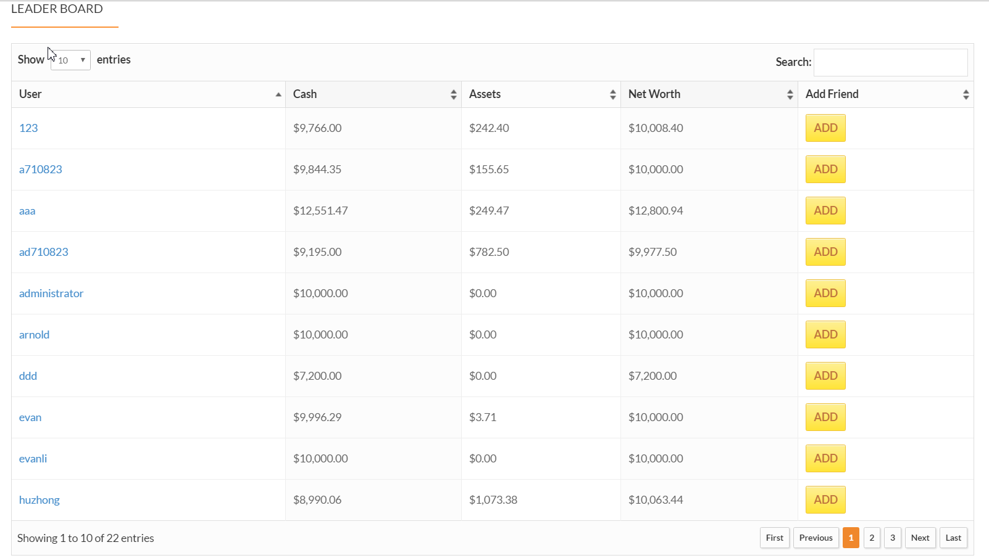

Figure 4 -leaderboard

In this page, it provides the information of all users. Otherwise, it also provides “add friend” function. User also can use search function to find a special friend.

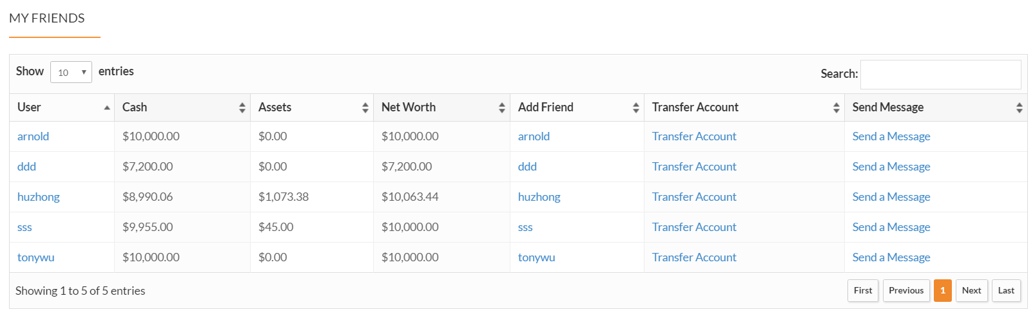

Figure 5- friend page

In the friend page, user can view the detail of friend. In this page, it provides two functions: transfer and sending message. User can transfer money to his/her friend. At the same time, user also can send message to his/her friends.

History & Current:

In this part, it has two functions: history and current information.

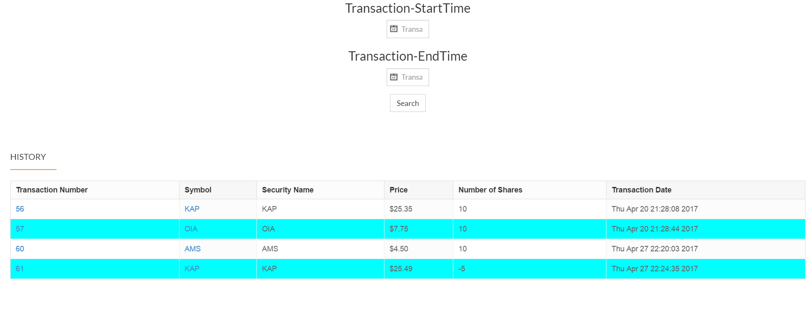

Figure 6-history

In the history page, user can view the history of trading.

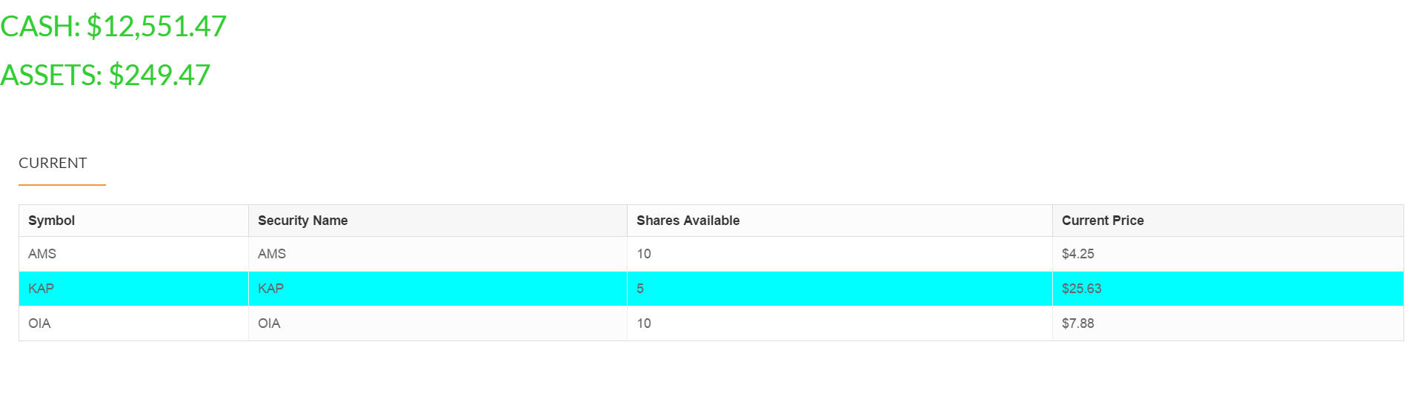

Figure 7-current

In the current, it shows the situation of current stocks.

Profile:

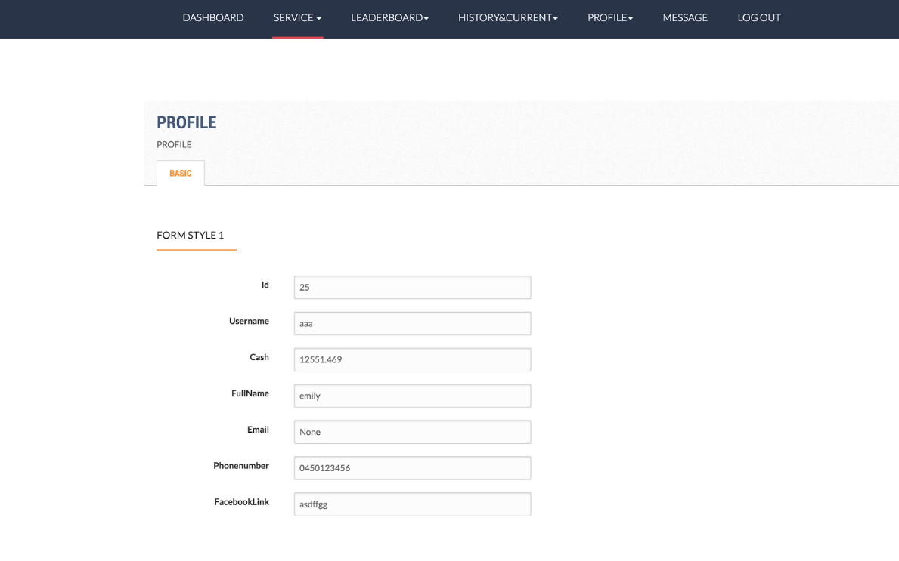

Figure 8-profile

In this page, it shows the detail of a user. At the same time, it also provides edit function for users

Message:

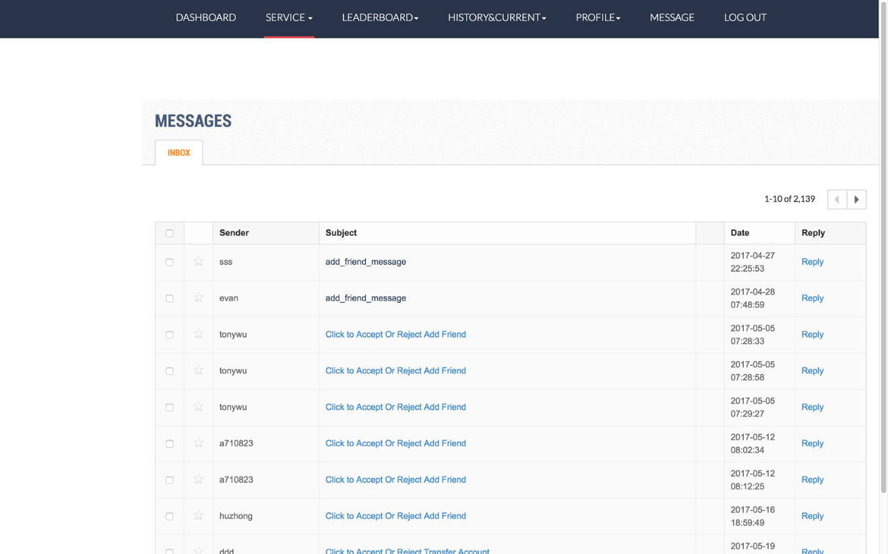

Figure 9-message

In this page, it shows simple content of each message. User can click the title to view the detail of a message.

Log out:

When user finish all activities, he/she can logout his/her account.